In caAERS, you can import XML files to minimize the amount of data entry that you need to perform, and you can export caAERS data to XML files so that it may be imported into another version of caAERS.
- For information about importing XML files into caAERS, see Importing XML Files.
- For more information about exporting XML files from caAERS, see Exporting from caAERS.

Importing XML Files
If you have previously used other applications and databases to maintain studies/protocols, subjects/participants, investigators, research staff, and organizations, you can import the data via an XML file instead of manually entering it. You must create separate XML files for each data type, e.g., Study file, Subject file, etc. Combining everything into a single XML file will cause the import to fail. If the file format you try to import does not mach the allowed format, the import will fail. To review copies of the XSD files and sample XML files, go to https://ncisvn.nci.nih.gov/svn/caaersappdev/branches/releases/caaers/1.9.2-stable/core/src/main/resources/schema/integration .
The following table lists where in the guide to refer to when importing different files.
Import | How to...
Investigators | Importing XML Files
MedDRA File | Importing a MedDRA File
Organizations | Importing XML Files
Report Definitions | Importing a Report Definition
Research Staff | Importing XML Files
Rules | Importing a Rule Set
Study | Importing XML Files
Subject | Importing XML Files
To import an XML file
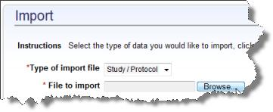
Note: To import a MedDRA terms file, see Importing a MedDRA File.
- Create an XML file containing the information you want to import.
- Click the Administration tab.
- Click Import in the task menu.
- Select the data that you want to import:
  - Study/Protocol
  - Subject
  - Investigators
  - Research Staff
  - Organizations
- Click Browse to locate and select the XML file that contains the information.
- Click Continue. The Review and Submit page opens.
- The system validates the XML file and show a synopsis of what will be imported.
  - If the file is invalid, there will be a description of the problem. Click Back to select another file or fix the file.
- If the information looks correct, click Import. This may take minutes to hours to complete.
- The Import Summary page opens.

Importing a MedDRA File
The caAERS installation includes the CTC v2 (Common Terminology Criteria) and CTCAE v3 (Common Terminology Criteria for Adverse Events) vocabulary. CTC is a free open-source medical vocabulary that can be used to code clinical studies. An alternative to CTC is MedDRA terminology. MedDRA is the Medical Dictionary for Regulatory Activities. This terminology is used to classify adverse event information associated with the use of biopharmaceuticals and other medical products. If your organization has a license to use MedDRA, the vocabulary can be imported into caAERS.
To import MedDRA files
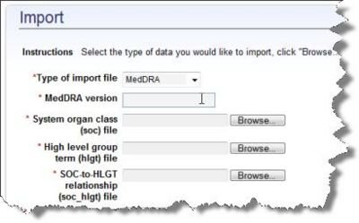
- Locate the folder where MedDRA is stored.
  - Note: The MedDRA files and folder must be located on the server that caAERS is installed on. You cannot import files from a folder that is located on the "client side" or desktop computer.
- Enter the name of the MedDRA version to be imported. This will be displayed in caAERS after import.
- For each of the following ascii files, click Browse to select the file location.
  - System organ class (soc) file
  - High level group term (hlgt) file
  - SOC-to-HLGT relationship (soc_hlgt) file
  - High level term (hlt) file
  - HLGT-to-HLT relationship (hlgt_hlt) file
  - Preferred term (pt) file
  - HLT-to-PT relationship (hlt_pt) file
- Once all the file locations are specified, click Import. You will see screen confirmation of the import process.
- The system validates the XML file and show a synopsis of what will be imported. </span>
  - If the file is invalid, there will be a description of the problem. Click Back to select another file or fix the file.
- If the information looks correct, click Import. This may take minutes to hours to complete.
- The Import Summary page opens.

Exporting from caAERS
The following table lists where in the guide to refer to export different files.
Export | How to...
Study | Exporting a Study
Subject
Investigators
Research Staff
Investigational New Drugs | Searching for and Exporting INDs
Organizations
Rules | Exporting Rules
Report Definitions | Exporting a User-Defined Adverse Event Report  IMPORTANT: If you are upgrading, you must first export your user-defined rules to an XML file (If you do not export your Rules to an XML before upgrading, those rules will be lost.) Once the upgrade is complete, then you can import the rules XML file back into caBIG caAERS.
Adverse Event Reports | - From the Adverse Events, Managing Reports option  - From the Adverse Events, Enter AEs, Review and Submit page

Research staff are individuals associated with a clinical trial conduct. If you want a person associated with the clinical trial to be able to log in, the user must be defined as a research staff member. For example, a user may be defined as an investigator, but if the user must log in and record information, they need to be added as a research staff member as well. You can search for and edit a research staff details and add a research staff user. To import an XML file containing research staff information, contact your caAERS administrator.
caBIG Clinical Trials Suite Users Only
- For considerations about adding users to the caBIG Clinical Trials Suite, see Adding Research Staff Users in The Suite.
- You can search for and update research staff information that resides in the NCI Enterprise Services. You may experience some delays if NCI Enterprise Services (COPPA) mode is enabled. For more information, see Searching for research staff in NCI Enterprise Services.

Contents
[hide]
- 1 Adding Research Staff Users in caBIG Clinical Trials Suite
- 2 Adding Research Staff Users to caAERS
- 3 Searching for Research Staff in NCI Enterprise Services - caBIG Clinical Trials Suite Users Only
- 4 Searching for and Editing Research Staff Details

Adding Research Staff Users in caBIG Clinical Trials Suite
The first step in creating new caBIG Clinical Trials Suite users is to request/create a user account in the local Dorian. For complete instructions, refer to The Suite Administration Guide, Creating Grid Users in Dorian.
When you add Suite users to caAERS, note that certain roles/users are necessary for The Suite's messaging functionality to work properly, and the users must be defined commonly across all Suite applications. This is discussed in The Suite Administration Guide, User Management.

Adding Research Staff Users to caAERS
When you add a research staff member to caAERS, you are also assigning a role/s to the user. The role filters the options and the data that the staff member will see. You will also specify whether the user will be able to log in to caAERS. If you want an investigator added to caAERS to be able to log in, the investigator must be added as a research staff user as well.
To add a research staff member to caAERS
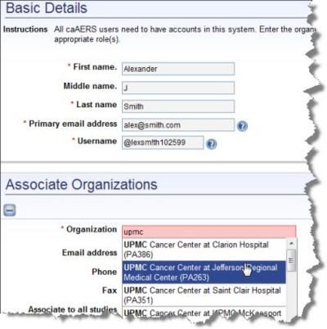
- Click the Administration tab.
- Click the Research Staff task.
- Click Create/Edit Research Staff. The Research Staff Details page opens.
- Enter the investigator's contact information
  - First Name
  - Middle Name, if desired
  - Last Name
  - Primary Email address
- Enter the Username to be used when the research staff member logs into caAERS. To log in as an investigator, the investigator must be defined as research staff member as well.
- Specify the oganization with which the investigator is associated. Enter the Organization name or a portion of the name. Select the organization from the list.
  - If an organization is not listed and cannot be found, you can add the organization. Click Add Organization at the bottom of the page, and enter the organization's name.
- Enter contact information for the research staff member:
  - Email address All notifications regarding changes to the user's account will be sent to this email account.
  - Phone number in the format ########## or ###-###-####
  - Fax number, if desired, in the format ########## or ###-###-####
  - Street Address, City, State, Postal code, and Country.
- If you are a caBIG Clinical Trials Suite user, enter the Grid Identity. In The Suite, the User ID is the Grid identity.
- Specify whether to Associate to all studies so that the research staff member can access information for all caAERS studies.
- Check off the user roles to which to assign a research staff member. For a description of each role, see Roles in caAERS. Access to the different areas of caAERS is controlled by the user roles and each user can be assigned to multiple roles. Note: An email will be sent to the research staff primary email address. Use the link in the email to set the password for the research staff member.
- Maintain the current Start Date or click the calendar icon to select a start date indicating when the research staff member will gain access to the user role.
- Click Save.
  - If you did not enter all of the required information in the appropriate format, you will need to return to the page and correct the information.
- If you entered information correctly, a message displays, Successfully saved the research staff.

Searching for Research Staff in NCI Enterprise Services - caBIG Clinical Trials Suite Users Only
The NCI Enterprise Services is a repository of clinical trial protocol abstraction, persons, organizations, and the associations between them. As a caAERS Suite user, you can search for a research staff user within NCI Enterprise Services, and update the information on NES from caAERS. To find a research staff user in NES, see caBIG User's Guide, Chapter 9, caAERS Integration with NES.

Searching for and Editing Research Staff Details
To search for a research staff user
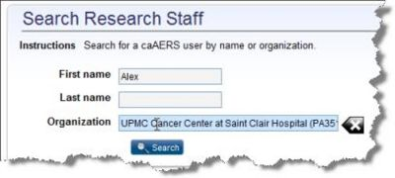
- Click the Administration tab.
- Click the Research Stafftask.
- Click Search Research Staff.
- You can fill in the following information to search for the research staff or you can leave all or some of the fields blank to expand the search results:
  - First Name and Last name of the research staff member.
  - Investigator number which is the identifier assigned to the NCI Investigator
- Enter the Organization name or a portion or the organization name with which the research staff is associated. Select the organization from the list.
- Click Search.
- The search results display at the bottom of the page. To navigate, sort, and filter the search results, see Finding a Search Result.
- To view and edit the research staff details, click on the First Name of a research staff member in the search results. Research Staff page opens.
- Edit the research staff details, and click Save.

Investigators are people associated with a clinical trial. You can search for and edit investigators and add an investigator. To import an XML file containing investigator information, contact your caAERS administrator.
caBIG Clinical Trials Suite Users Only You can search for and update investigator information that resides in the NCI Enterprise Services. You may experience some delays if NCI Enterprise Services (COPPA) mode is enabled. For more information, see Searching for investigators in NCI Enterprise Services.

Adding an Investigator to caAERS
If you want an investigator to be able to log into caAERS, you must add the investigator to caAERS as a Research Staff User as well.
To add an investigator to caAERS
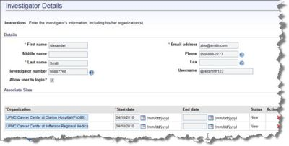
- Click the Administration tab.
- Click the Investigator task.
- Click Create/Edit Investigator. The Investigator Details page opens.
- Enter the investigator's contact information:
  - First Name
  - Middle Name, if desired
  - Last Name
  - Email address
  - Phone number in the format ########## or ###-###-####
  - Fax number, if desired, in the format ########## or ###-###-####
- Enter the Investigator Number, if desired, which is the identifier assigned to the NCI Investigator.
- Specify whether to Allow User to log in?. If you want the investigator to be able to log into caAERS, check this box and add them to caAERS as a Research Staff User.
- Specify the information about the oganization with which the investigator is associated:
  - Enter the Organization name or a portion of the name. Select the organization from the list.
    - If an organization is not listed and cannot be found, you can add the organization. Click Add Organization and enter the organization's name.
  - Enter the Start Date indicating when the investigator can access this role in the format MM/DD/YYY or click the calendar icon and select the date. This date is required.
- Enter the End Date. This is not required.
  - To delete an organization from the investigator's record, click the x on the right side of the organization row.
- Click Save.
- If you entered information correctly, a message displays, Successfully saved the investigator.

Searching for an Investigator in NCI Enterprise Services - caBIG Clinical Trials Suite Users Only
The NCI Enterprise Services is a reposity of clinical trial protocol abstraction, persons, organizations, and the associations between them. As a caAERS Suite user, you can search for a study within NCI Enterprise Services, and update the information on NES from caAERS. To find an investigator in NES, see The Suite User's Guide, Chapter 9, caAERS Integration with NES.

Searching for and Editing Investigator Details
To search for and edit investigator information
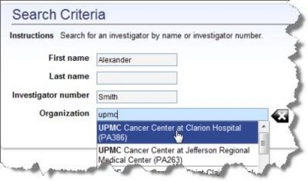
- Click the Administration tab.
- Click the Investigator task.
- Click Search Investigator.
- You can fill in the following information to search for the investigator or you can leave all or some of the fields blank to expand the search results:
  - First Name and Last name of the investigator
  - Investigator number which is the identifier assigned to the NCI Investigator.
- Enter the Organization name or a portion of the organization name with which the investigator is associated. Select the organization from the list.
- Click Search.
- The search results display at the bottom of the page. To navigate, sort, and filter the search results, see Finding a Search Result.
- To view and edit the investigator details, click on the First Name of an investigator in the search results.
- To update the Investigator Details page, see Filling in the Investigator Details Page.
- Click Save.

As a caAERS administrator, you can add Investigational New Drugs (IND) to caAERS for use in studies. By adding the IND information, adverse events related to a particular IND can be tracked more efficiently. When you perform a search of INDs, you can export the results to a .CSV file.

Adding an IND
To add an Investigational New Drug (IND)
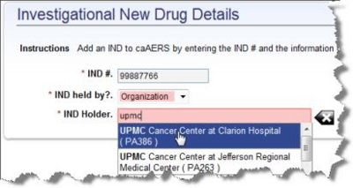
- Click the Administration tab.
- Click the IND# the task.
- Click Create IND#.
- Enter the IND # or the number that identifies the Investigational New Drug.
- Click IND held by? and select Organization or Investigator to indicate the organization or person who holds the IND.
- Use IND Holder to search for the organization or investigator:
  - If an IND is held by or sponsored by an Investigator, enter the first or last name or a portion of the first last name. Select an investigator from the list.
  - If the IND is held by an Organization, enter the name or a portion of the organization name. Select an organization from the list.
- Click Save.

Searching for and Exporting INDs
To search for an Investigational New Drug (IND)
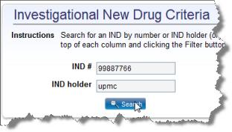
- Click the Administration tab.
- Click the IND# task.
- Click Search.
- To list all INDs in the search results, leave the fields blank and click Search.
- Enter the IND #.
- Enter the name of the investigator or organization who distributes the IND as the IND holder.
- Click Search.
- The IND results are listed at the bottom of the page. To navigate, sort, and filter the search results, see Finding a Search Result.
- To export the list of INDs, click the file icon above the Clear button. Follow the prompts to export the results to a .CSV file.

